APPLICATION CONTROLLER PATTERN

It creates a central point for handling the flow and screen navigation of an app

All the code for flow and navigation should be in the controller.

WHY USE THIS PATTERN?
-To save you work,
- You can reuse action and view management code

EXAMPLES OF APPS THAT USE THIS PATTERN
-Tutorials when you get a new app, tons of screens that need to be navigated through
-Install Wizards

DIAGRAMS

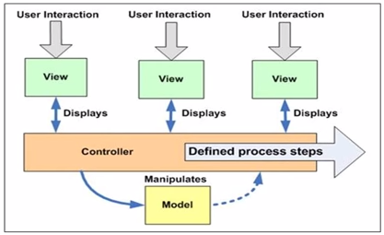



SOURCES:
https://www.youtube.com/watch?v=dB6DL2R86nw
http://corej2eepatterns.com/ApplicationController.htm
http://c2.com/cgi/wiki?ApplicationController

